
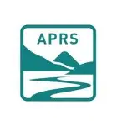

Fed up with the Scottish Planning System? Renewable energy developments taking over the Highlands?

Nairn River Community Council
is proud to host an evening with

PLANNING DEMOCRACY
and
Action to Protect Rural Scotland

in the Golf View Hotel, Seabank Road, Nairn
at 7:00 – 9:00pm Monday 9th March 2026

The PD/APRS Team will talk about their work, present their Manifesto to radically improve Scotland’s planning system

Putting People, Nature, Climate and
Community Power at its core.
Shifting the System built for Private Profit
to a
System grounded in Public Good.

You are cordially invited to come along, to listen and to express your views.

https://www.planningdemocracy.org.uk

